GOBUSTER TOOL – COMPREHENSIVE TECHNICAL DOCUMENTATION
A High-Speed Directory, File, DNS, and Virtual Host Enumeration Tool for Ethical Hacking

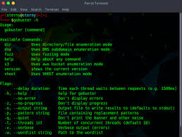
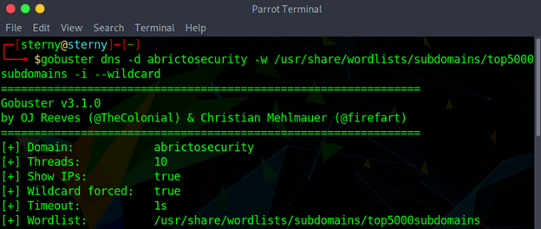
4

ABSTRACT
Modern web applications often expose a large attack surface through hidden directories, files, subdomains, and virtual hosts. Manual discovery of these resources is impractical due to scale and complexity. This document presents a comprehensive technical study of Gobuster, a fast and flexible enumeration tool widely used in ethical hacking and penetration testing. The report explains the theoretical background, internal working mechanism, operational modes, command usage, practical case studies, advantages, limitations, and defensive considerations. The objective of this documentation is to provide an academic and practical understanding of Gobuster suitable for cybersecurity coursework, lab records, interviews, and professional penetration testing engagements.

1. INTRODUCTION
Web servers rarely expose all their functionality through visible links. Developers often leave behind administrative panels, backup files, API endpoints, and test environments that are not intended for public access. Attackers frequently exploit these hidden resources to gain unauthorized access or sensitive information.
Web enumeration is the systematic process of discovering such hidden resources. Tools like DIRB pioneered this approach, but modern applications require faster, more scalable solutions.
Gobuster was developed to address these challenges by providing a high-performance, multi-threaded brute-force enumeration tool capable of discovering web directories, files, DNS subdomains, and virtual hosts efficiently.

2. OBJECTIVE OF THE STUDY
The objectives of this documentation are:
- To understand modern web and DNS enumeration techniques
- To study the working mechanism of Gobuster
- To analyze Gobuster modes and command usage
- To demonstrate real-world usage through practical case studies
- To evaluate strengths, limitations, and security implications
- To provide exam-ready and submission-ready content

3. BACKGROUND: WEB & DNS ENUMERATION IN CYBER SECURITY
Enumeration is a critical step in the Scanning & Enumeration phase of penetration testing. It focuses on identifying:
- Hidden directories and files
- API endpoints
- Subdomains and DNS records
- Virtual hosts hosted on the same IP
Unlike vulnerability scanners, enumeration tools focus on resource discovery, which often leads to high-impact findings when misconfigurations exist.
Gobuster is designed to perform this task at high speed using efficient concurrency.

4. OVERVIEW OF GOBUSTER TOOL
Gobuster is an open-source enumeration tool written in Go (Golang), which provides excellent performance and concurrency. It is included by default in Kali Linux and widely used by penetration testers and bug bounty hunters.
Gobuster supports multiple enumeration modes:
- Directory/File Enumeration
- DNS Subdomain Enumeration
- Virtual Host (VHOST) Enumeration
- S3 Bucket Enumeration (limited use cases)
Gobuster does not exploit vulnerabilities directly. Its purpose is to identify existing but hidden resources that can later be tested for security weaknesses.

5. ARCHITECTURE AND WORKING MECHANISM

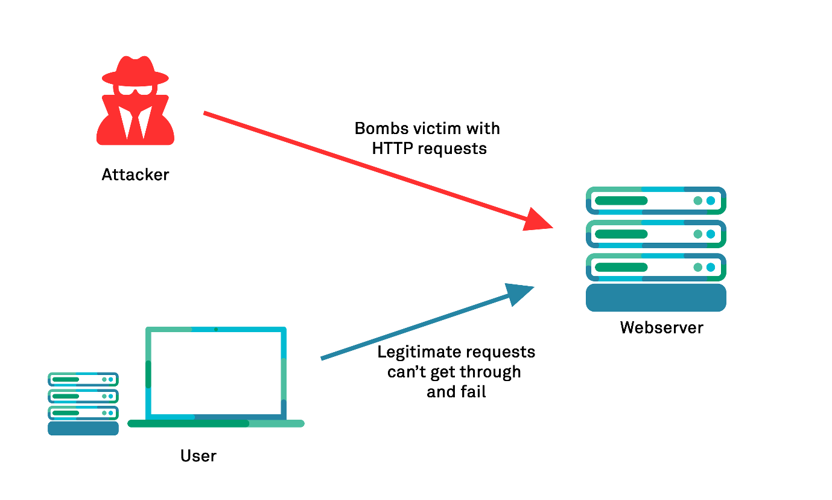
Gobuster follows a multi-threaded brute-force architecture:
- Target Definition
The user specifies the target URL, domain, or IP.
- Wordlist Loading
A wordlist containing potential resource names is loaded.
- Concurrent Request Engine
Multiple requests are sent in parallel using goroutines.
- Response Evaluation
HTTP status codes, DNS responses, or host headers are analyzed.
- Result Reporting
Valid resources are displayed and optionally saved.
This architecture makes Gobuster significantly faster than legacy tools.

6. INSTALLATION AND ENVIRONMENT
Gobuster is pre-installed in Kali Linux.
To verify installation:
gobuster --help
Gobuster requires no special privileges and works on HTTP, HTTPS, and DNS-based targets.

7. OPERATIONAL MODES OF GOBUSTER
Gobuster supports multiple operational modes, making it a versatile enumeration tool.
7.1 Directory / File Enumeration Mode
Used to discover hidden directories and files on web servers.
7.2 DNS Enumeration Mode
Used to brute-force subdomains of a target domain.
7.3 Virtual Host (VHOST) Enumeration Mode
Used to identify multiple websites hosted on the same IP using different Host headers.

8. COMMAND USAGE AND ANALYSIS
8.1 Directory Enumeration
gobuster dir -u http://example.com -w /usr/share/wordlists/dirb/common.txt

8.2 Specify File Extensions
gobuster dir -u http://example.com -w wordlist.txt -x php,html,txt

8.3 DNS Subdomain Enumeration
gobuster dns -d example.com -w subdomains.txt

8.4 Virtual Host Enumeration
gobuster vhost -u http://192.168.1.10 -w vhosts.txt

8.5 Save Output to File
gobuster dir -u http://example.com -w wordlist.txt -o gobuster_results.txt

9. PRACTICAL CASE STUDY
Scenario
A penetration tester assesses a web server hosted on an internal network.
Execution
gobuster dir -u http://192.168.146.131 -w /usr/share/wordlists/dirb/common.txt
Observations
- Discovered /admin/ login panel
- Identified /uploads/ directory
- Found /api/ endpoint
Impact Analysis
These findings exposed sensitive application functionality and enabled further testing such as authentication bypass, file upload abuse, and API exploitation.

10. ADVANTAGES OF GOBUSTER
- Very fast and multi-threaded
- Supports multiple enumeration modes
- Highly configurable
- Modern and actively maintained
- Ideal for labs, CTFs, and real-world pentests

11. LIMITATIONS OF GOBUSTER
- Purely brute-force based
- Depends heavily on wordlists
- No recursive crawling
- Generates noticeable traffic

12. GOBUSTER VS OTHER WEB ENUMERATION TOOLS
Tool | Speed | Features | Best Use Case
Gobuster | High | Dir, DNS, VHost | Modern web enumeration
DIRB | Medium | Basic directory scan | Learning & labs
Feroxbuster | High | Recursive scans | Deep enumeration
WFuzz | Medium | Fuzzing-based | Parameter testing
Gobuster is best suited for fast and controlled enumeration.

13. SECURITY AND DEFENSIVE CONSIDERATIONS
Organizations can defend against Gobuster-style attacks by:
- Implementing rate limiting
- Using Web Application Firewalls (WAF)
- Removing unused files and directories
- Enforcing strong access controls

14. LEGAL AND ETHICAL CONSIDERATIONS
Gobuster must only be used on systems where explicit authorization has been granted. Unauthorized brute-force enumeration may violate cyber laws and organizational policies.

15. CONCLUSION
Gobuster is a powerful and efficient enumeration tool that reflects the evolution of web reconnaissance techniques. Its speed, flexibility, and multi-mode support make it a preferred choice for modern penetration testing. Mastering Gobuster provides cybersecurity students and professionals with a strong foundation in web and DNS enumeration.

16. REFERENCES
- Kali Linux Documentation
- OWASP Web Security Testing Guide
- Gobuster GitHub Repository

